# Pre Bill Load Accounts - Auditor

It shows all the **PRE-BILL** accounts of different hospitals which have been assigned to an   
auditor. For viewing accounts of a particular hospital, select the hospital ID from the filter panel available on the left side and the application will display all the accounts of that particular facility.

If no account is pending for review, the auditor will get the message **“No Account Review is   
 “Pending for the Facility”.**

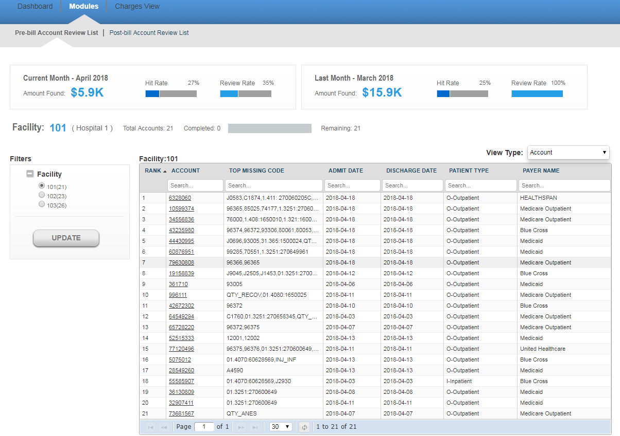

**View Type** : Grouping accounts based on Code and payer. There are 3 options available in dropdown.

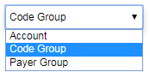

* **Account (Default)**
* **Code Group**
* **Payer Group**

**Account** : This the default view for showing accounts. accounts are coming based on hospitalId and accountId

**Code Group**: - This is showing tree view of accounts based on [hospitalId-accountid-predcodeClassifications]. 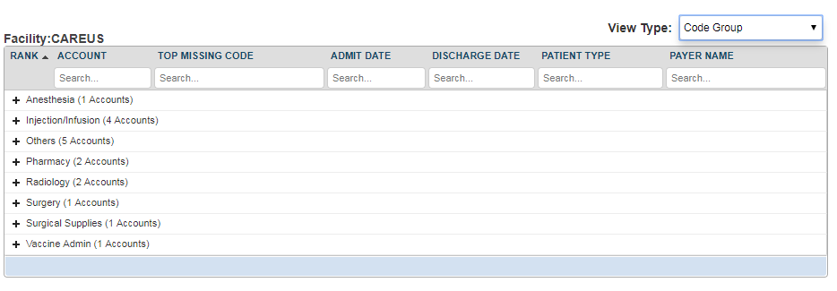

**Payer Group**:- - This is showing tree view of accounts based on [hospitalId-accountid-PayerCode].

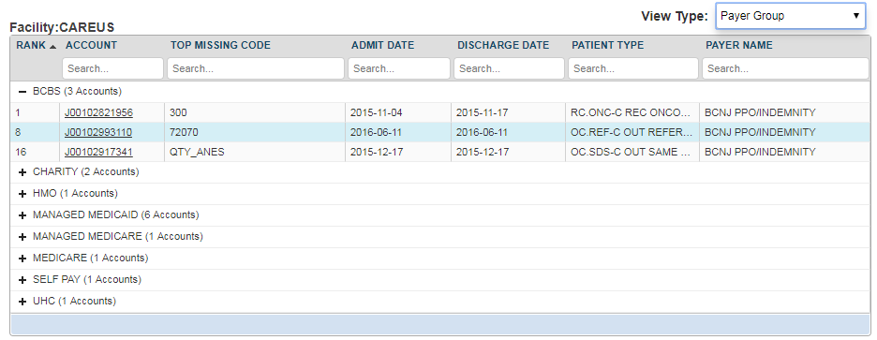

You will view the following details for a particular account.

* **Account:** It refers to the patient identification number.
* **Top Missing Code:** It refer to the missing code find for this account.
* **Admit Date:** It is the date when patient got admitted to the hospital.
* **Discharge date:** This is the date when patient got discharged from the hospital.
* **Patient Type:** There can be different types of patients. For example, OUTPATIENT, INPATIENT and EMERGENCY.
  + OUTPATIENT care is any healthcare service provided to a patient who is not admitted to a hospital.
  + INPATIENT care is any healthcare service provided to a patient who is admitted to a hospital.
  + EMERGENCY care is provided to the patients who need urgent care because of the illness or accident.
* **Payer Name:** This is the name of the insurance company.

All the above fields are searchable. You can navigate through multiple pages of records by making use of navigation bar given at the bottom of the screen. Enter a specific page number and you will jump to that specific page.

Above the account’s grid, you will view two widgets for other details like the **Amount Found**, **Hit Rate** and the **Review Rate** for the past month and the current month.



**Hit Rate:**  It refers to the percentage of accounts on which the auditor has agreed for missing charges.

The Hit Rate of an auditor can be calculated by using the below formula:

**Number of accounts Agreed / Total number of reviewed accounts**

**Review Rate:** It refers to the percentage of accounts reviewed by the auditor.

The Review Rate of an auditor can be calculated by using the below formula:

**Number of accounts Reviewed by an auditor/Total number of accounts assigned to an auditor**

Click on any account and you are directed to the “**PRE-BILL ACCOUNT DETAILS“**  page.

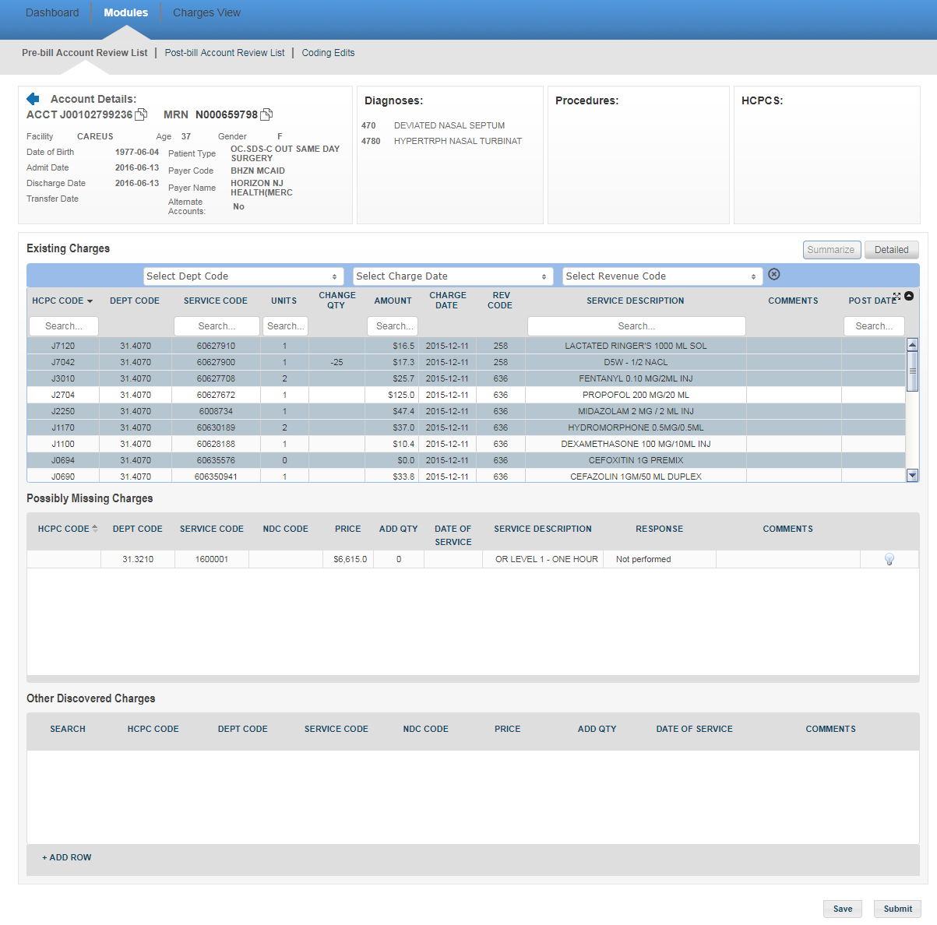

The user can view the account’s personal information like Age, Gender, Date of Birth, Admit Date, Discharge Date, Transfer Date, Patient Type, Payer Code and the Payer’s name on the top-left of the screen. You can also see information about alternate accounts for the same patient (An alternate account is an account with the same Patient ID and same Admit or Discharge Date as the original account). Towards the right, you will find the details about various diagnoses codes, Procedure codes and HCPCs on the account.  You can also use the scroll bar in individual Diagnosis/Procedure/HCPC sections in case the list is long.

You will view **“Existing Charges”, “Possibly Missing Charges”** and **“Other Discovered Charges”**below.

**Existing Charges:**  These charges will include all the hospital charges for treatment and services rendered to the patient. The auditor will audit these charges and can make changes in the quantity, enter his comments and can directly submit the data OR save the information for later purpose without submitting. In the existing charges section, there are two alternate views that the auditors can toggle between. The **Summarized** view is a summed-up view based on the HCPC/charge Code, department, charge date and description. The **Detailed** view is the usual detailed existing charges view. A Blue row in summarized view indicates that once you expand to Detailed view, you’ll be able to see multiple transactions for the same charge.

There are three filters at the top (**Dept Code, Charge Date, and Revenue Code**) using which you may filter the data that is shown in the existing charges table. In the dropdown, you should be able to see the code, description and the total charges amount for the same. Please find below, a screenshot of the same with the dropdown for Revenue Code.

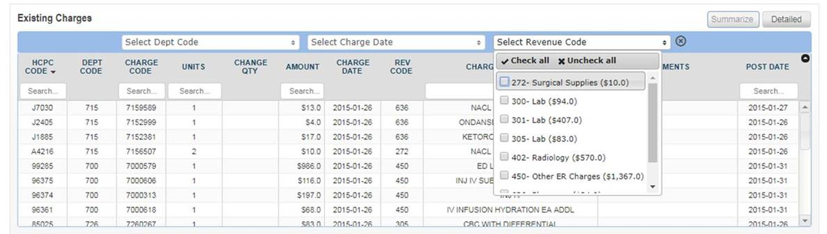

You may select **multiple codes from each of the filters** as per preference and the below table would get updated with the corresponding data. For example, if you were to select revenue codes 272, 300, 301 and dept code 723 in the above table, the below view would be shown. You may click on the cross on the right of the last filter to remove all filters selected.

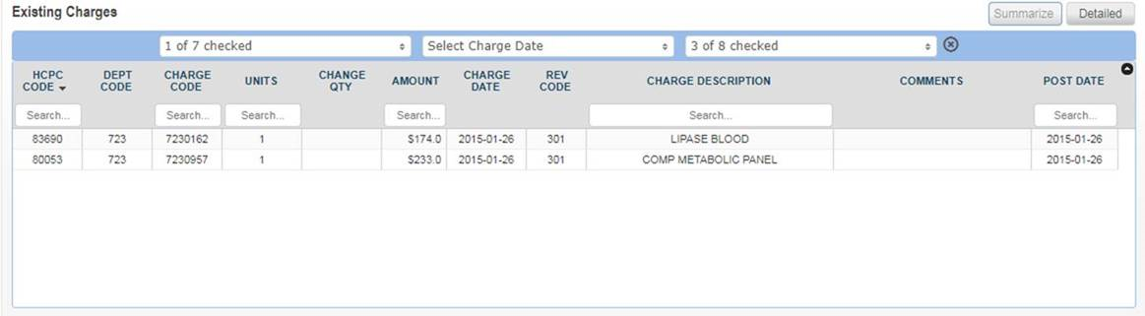

The Existing Charges grid has following columns:

* HCPC Code: This is the healthcare common procedure code.
* DEPT Code: This is the department code of the patient.
* Charge (Service) Code: This is the code associated with the charge in a facility and department
* Units: This is the medication dose which is given to a patient.
* Change Quantity: If an auditor feel there should be some change in quantity, he can change the quantity and enter the updated quantity.
* Amount: This is the amount of the units consumed by the patient.
* Charge Date: This is the date on which the patient is charged.
* Rev Code: This is the revenue code associated with the charge code
* Service Description: This is a brief description about the various charges incurred on the patient.
* Comments: The auditor can write his comments in the area provided.
* Post Date: This is the date when the charge was added to the account

You may also search for codes on the account by typing in the search box below each column in the table.

**Possibly Missing Charges:**We use our software solutions to identify missing charges. The auditor can audit the missing charges and give the response.  If auditor agrees for missing charges for an account, the response “**Agree**” can be selected, else any other response from the drop-down list can be selected. After selecting the response, please enter comments as well.

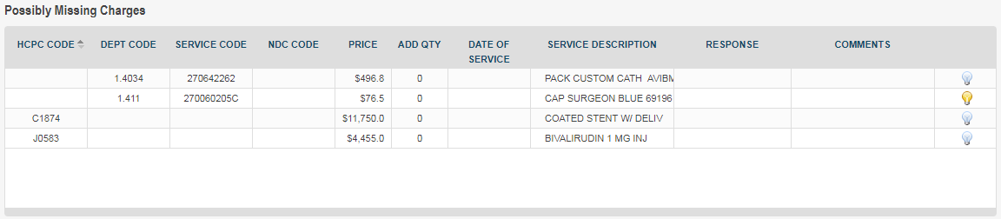

The possibly missing charges grid has following columns:

* HCPC Code: These codes are numbers assigned to every task and service a medical practitioner may provide to a patient including medical and diagnostic services.
* DEPT Code: Each department in a hospital has a specific code. It conveys essential information quickly without any misunderstanding.
* Charge (Service) code: This is the code associated with the charge in a facility and department
* NDC Code: This is a code used for Pharmacy charges
* Price: This refers to the price of the item/procedure
* ADD QTY: This is the quantity of the item to be added
* Date of Service: This is the date on which the charge is administered.
* Charge (Service) Description: This is a brief description about the various charges incurred on the patient.
* Response: The auditor can select the response from the drop-down list. If the agrees for the missing charges, he can select the option “Agree”from the drop down list. Accordingly, he can select a different response from the drop down list based on his review. For example, if the auditor feels there is no documentation for this account, he can select the option “Documentation is not available for review”.
* Comments: The auditor will enter his comments in the area provided.
* Tool tip (Lightbulb): This feature can be used to share knowledge obtained on review of same code previously across auditors. It is basically a comment box which can be used by auditors to add information to make it easier for other auditors reviewing the same code. If the bulb is yellow, it means that there are comments already added for the prediction.

**Other Discovered Charges:** These are the charges other than the existing and the missing charges.  This option enables the auditor to add some other miscellaneous charges which could have been missed for a particular account. The auditor can easily search the details even if he knows initial two or three letters of  “**Department Code**” or “**Charge Code**”.

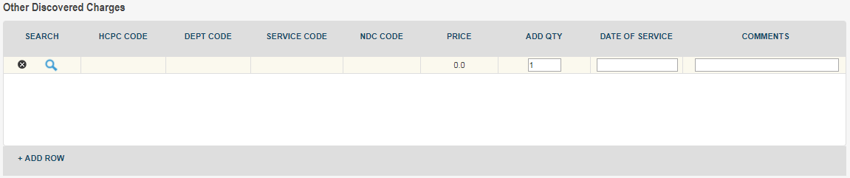

The “Other Discovered Charges” grid has following columns:

* Search: This allows the auditor to search the code to be added in the row
* HCPC Code: These codes are numbers assigned to every task and service a medical practitioner may provide to a patient including medical and diagnostic services
* Department Code: Each department in a hospital has a specific code. It conveys essential information quickly without any misunderstanding.
* Charge (Service) Code: This is the code associated with the charge in a facility and department
* NDC Code: This is a code used for Pharmacy charges
* Price: This refers to the price of the item/procedure
* Add Quantity: This is the quantity of the item to be added
* Date of Service: This is the date on which the charge is administered
* Comments: The auditor will enter his comments in the area provided

The auditor can click on the plus (+) sign  to add a new row to the grid. Clicking on the Search icon will display the “**Other Discovered Charges search form”.**

In search mode, you may use the drop down box to select key criteria by which to search and you may enter those criteria in whole or part. It has four options available for doing the basic search.

1. Equals
2. Begins with
3. Ends with
4. Contains

* **Equals**: The search results will include only the letters you specify.  For example, entering “LINEN SAVERS” as your search string for “Service description” would return only one result for the given charge description. Similarly, if you enter “5412”as the “Service code”.  It will display the record with the matching charge code.
* **Begins with**: The search result will have all of the letters in the beginning which you entered in the search criterion.  For example, entering “Department Code” as “41” will return any Department Code that begins with “41”.
* **Ends with**: The search results will have all the letters or numbers included   in the end.  For example, entering “12”as a search string for  “ Department  Code”  will fetch records  like “312”, “412”, “512” .
* **Contains**: The search results will have all of the letters   included anywhere in the results which you entered as a search criterion.  For example, entering “Emer” as your search String for “Department Description”   might return results like “Emergency”, “Emergency OPD”, “Emergency Cardiac” etc.

There are four steps to perform a basic search.

1. Select the search criterion from the drop down box.
2. Enter all or part of the search string.
3. Click the **“Submit”**
4. Review the search results and select the appropriate record.

In the screenshot below, we see that the user elected to search by “**Department code”** using “**equals”** as search criterion.

The auditor can select any specific record and double click on it. The values will be populated in the “**Other Discovered Charges**“ grid.  The auditor can enter his comments on the same.

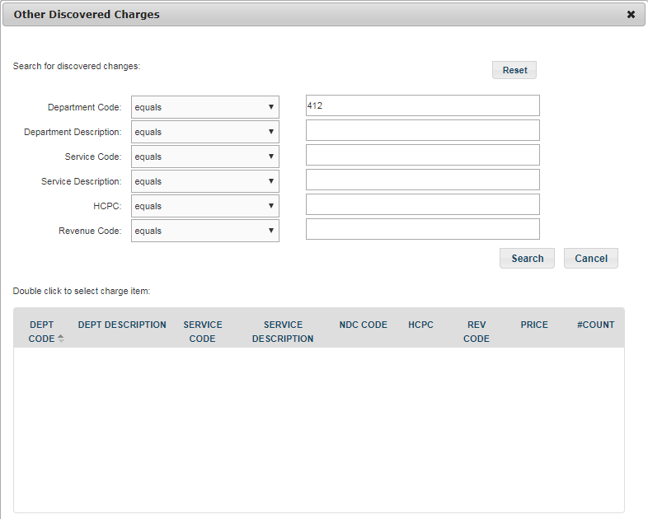

The auditor can enter the information and click on “**Save”** button. The information will be saved and the account’s row will be highlighted in blue Color in **“Accounts Review** **List”** page. When the auditor logs into the application next time, he knows that changes have been done for this account but they are not yet submitted.   If the auditor clicks on the **“Submit”** button, the information gets saved and the account is removed from the **“Accounts Review List”** page.